**Problem 2**

1. According to the model summary below, it is appropriate to include just the predictor “Ht” in the model, because after selecting Ht, the remaining model has no significant predictor.

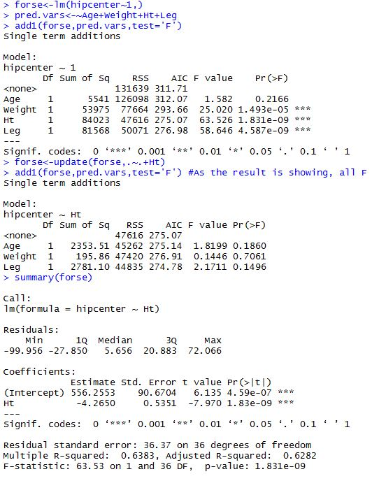

1. According to the backward elimination output below, we can conclude that the predictor to be included in the model is Ht, which is the same as what we obtained via forward selection.

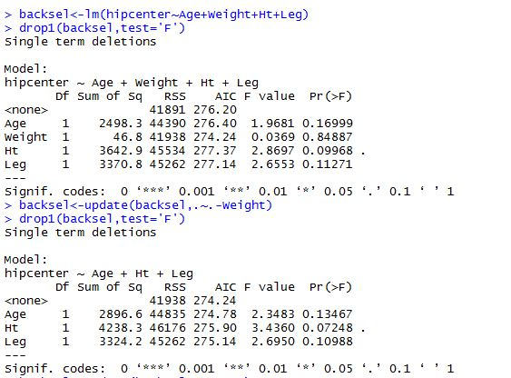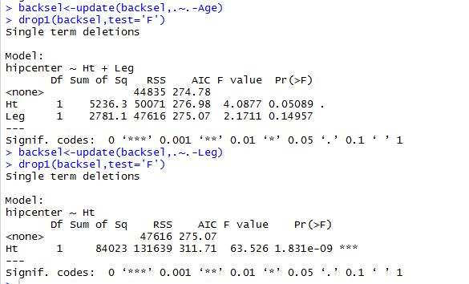

1. According to the output below, the 3rd sub-model has the smallest Cp, which equals to 3.04. And turns out the predictors in this model are Age, Ht, ad Leg.

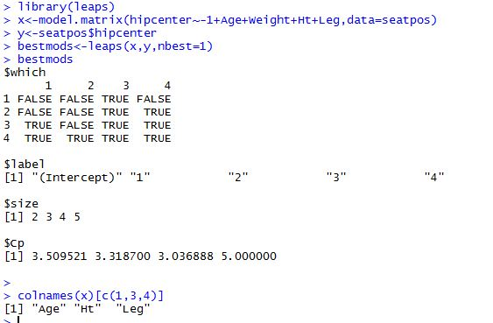

Problem 3

1. The predictors included in the model are Girth, Height, Girth^2, Height^2, and Girth*Height.

The model summary is as below:

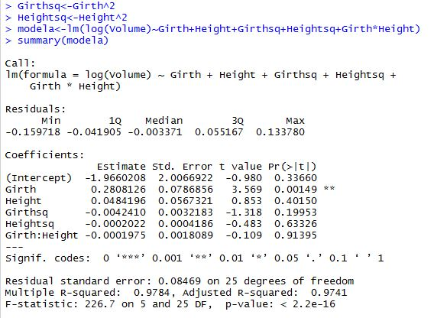

1. In the above second-order polynomial model, Girth is the only IV that is significant at alpha=.05 level.
2. I conducted a model selection using the leaps function, and according to the output below, the 3rd sub-model has the smallest Cp, which equals to 2.36, and predictors included in the model are Girth, Height, and Girth^2. I ran the simplified model with these three predictors, and the output shows that all regression coefficients are significant at alpha=0.05 level, with R^2 as high as .98.

